页面间的链接使用相对路径 (避免打开页面时无法显示其中的图片等)。

必须有一个主页， 文件名为 index.html， 主页中包括对其它分页面的链接，

并能返回寝室主页。其它分页面能返回主页。

寝室主页：http://yt-py.gitee.io/dong-shi-san-dormitory-619-website

文件命名及大小要求:

¬ 主文件夹下应该有一个主页文件，名为 index.html。

¬ 主文件夹下应包括 image、 web 两个文件夹，分别用来存放动画文件、图

片文件及网页文件等。

¬ 所有文件的总大小应控制在 100M 以内 (去掉多余的图片和动画)

导航栏要求：上方有个类似下图的导航栏，五个格子，文本内容分别是：HOMEPAGE,GALLERY,MUSIC,EXTRACTS,CONTACT

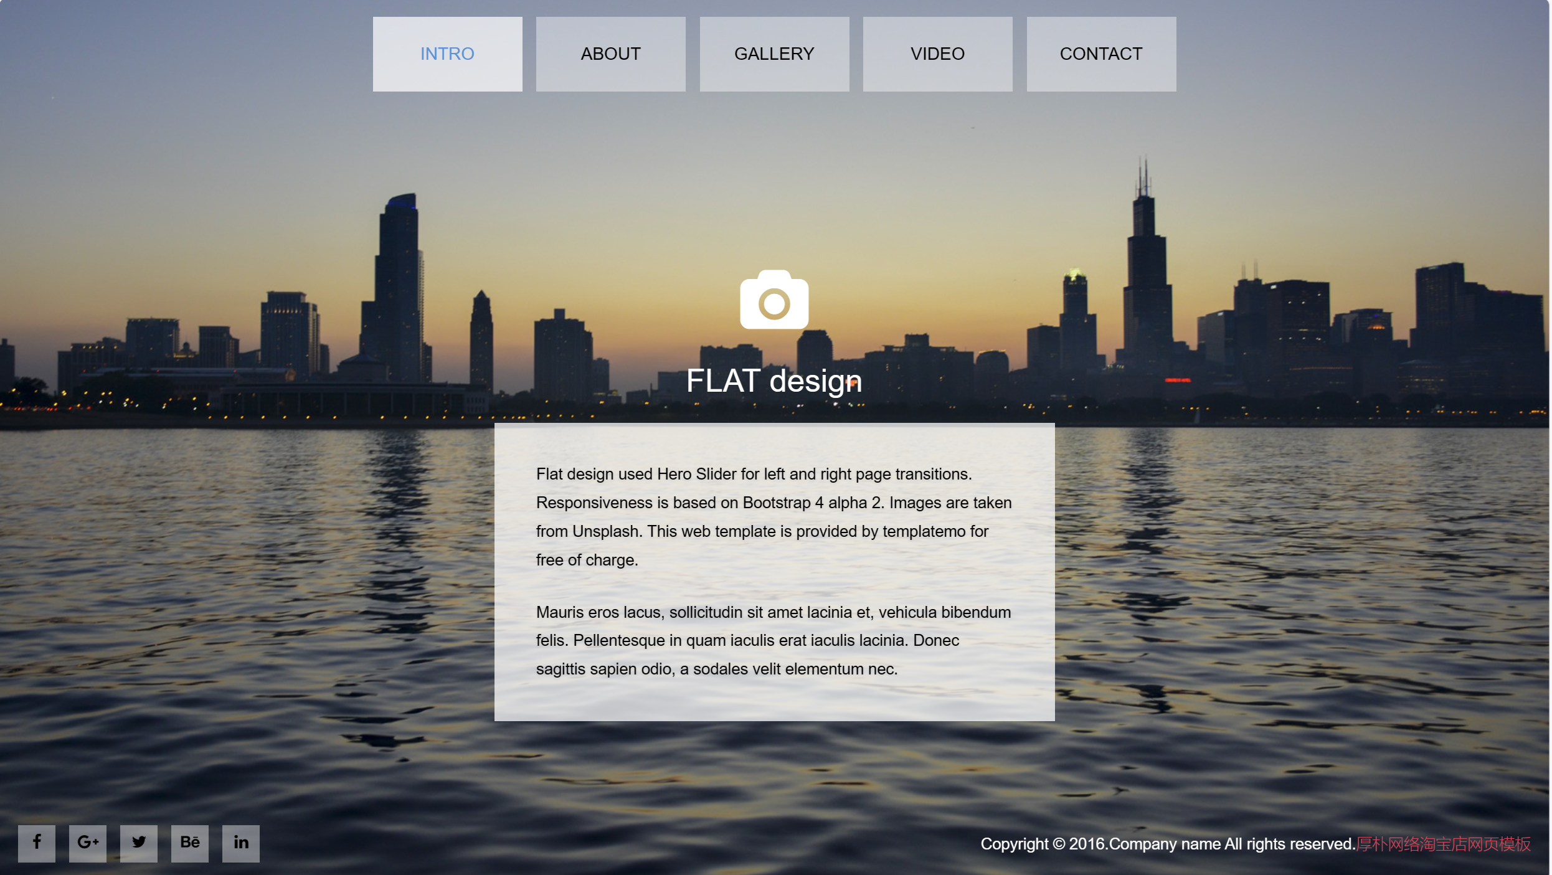

（HOMEPAGE）主页要求：

布局和上图一样，有个大背景图（已经放在文件里了），居中偏下放一个白框，右下方设计一个返回寝室主页的超链接按钮，白框上方大字HOMEPAGE，白框里面文本内容：

欢迎来到XXX的个人主页。

If I never see you again, good morning, good afternoon, and good night.

（GALLERY）第二页要求：

同样背景，然后像下图放照片就行。照片和背景放文件里了。



(MUSIC)第三页要求：

同样背景，三个白框，白框上面放图片下面放文字

文字内容（左对齐）：

左一：

《Chicago Freestyle》

Drake/Giveon

Dark Lane Demo Tapes(2020)

中间：

《N95》

Kendrik Lamar

Mr. Morale & The Big Steppers(2022)

右边：

《DON’T YOU LIE》

Offset

SET IT OFF(2023)

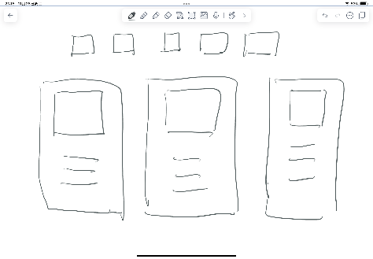

第四页要求：

同样背景，分别如下图输入两段文字。

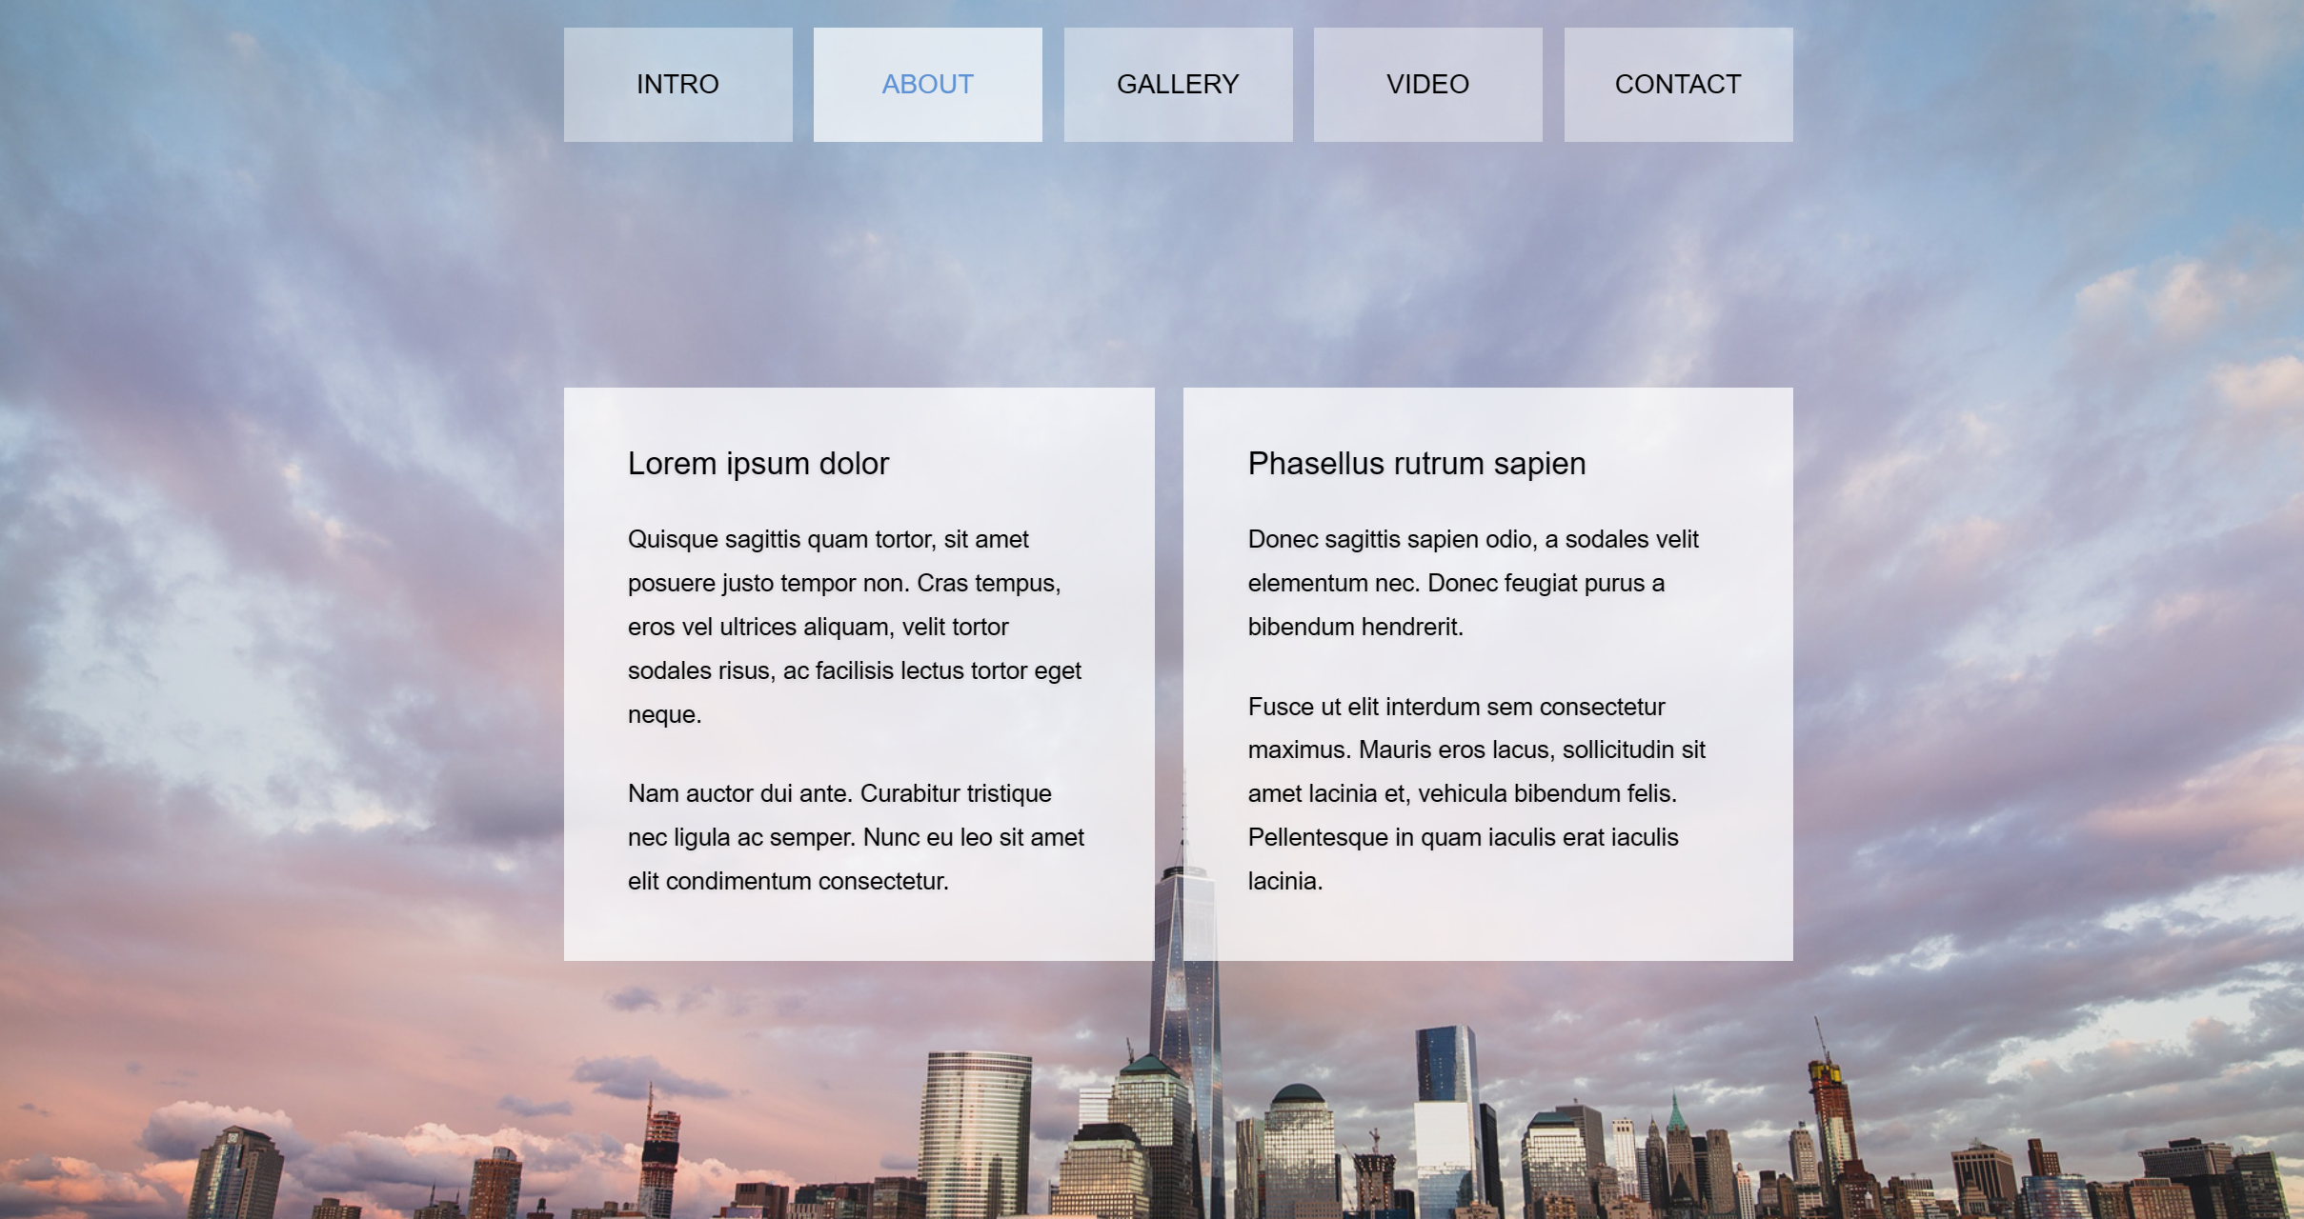

文段1：

Youth is not a time of life; it is a state of mind; it is not a matter of rosy cheeks, red lips and supple knees; it is a matter of the will, a quality of the imagination, a vigor of the emotions; it is the freshness of the deep springs of life.

Youth means a temperamental predominance of courage over timidity, of the appetite for adventure over the love of ease. This often exists in a man of 60 more than a boy of 20. Nobody grows old merely by a number of years. We grow old by deserting our ideals.

Years may wrinkle the skin, but to give up enthusiasm wrinkles the soul. Worry, fear, [self-distrust](https://www.zhihu.com/search?q=self-distrust&search_source=Entity&hybrid_search_source=Entity&hybrid_search_extra=%7B%22sourceType%22%3A%22article%22%2C%22sourceId%22%3A%22105694769%22%7D) bows the heart and turns the [spirit back to dust](https://www.zhihu.com/search?q=spirit%20back%20to%20dust&search_source=Entity&hybrid_search_source=Entity&hybrid_search_extra=%7B%22sourceType%22%3A%22article%22%2C%22sourceId%22%3A%22105694769%22%7D).

文段2：

Whether 60 or 16, there is in every human being’s heart the lure of wonders, the unfailing appetite for what’s next and the joy of the game of living. In the center of your heart and my heart, there is a wireless station; so long as it receives messages of beauty, hope, courage and power from man and from the infinite, so long as you are young.

When your aerials are down, and your spirit is covered with snows of [cynicism](https://www.zhihu.com/search?q=cynicism&search_source=Entity&hybrid_search_source=Entity&hybrid_search_extra=%7B%22sourceType%22%3A%22article%22%2C%22sourceId%22%3A%22105694769%22%7D) and the ice of pessimism, then you’ve [grown old](https://www.zhihu.com/search?q=grown%20old&search_source=Entity&hybrid_search_source=Entity&hybrid_search_extra=%7B%22sourceType%22%3A%22article%22%2C%22sourceId%22%3A%22105694769%22%7D), even at 20; but as long as your aerials are up, to catch waves of optimism, there’s hope you may die young at 80.

第五页要求：

同样背景，居中三个白框

第一行：QQ:1695071559

第二行：WeChat:d13338650595

第三行：Phone:13338650595